**27 КОМПОНВКА И ЭЛЕМЕНТЫ УПРАВЛЕНИЯ WPF**

Задание 1 В работе 24 «Язык разметки XAML». Измените интерфейс проекта WPF – XmlTaskWPF следующим образом:

добавить возможность скрывать функциональность под ЭУ Expander;

предложите выбор вывода списка в качестве Компонеты с использованием RadioButtons;

добавить вывод списка элементов в TreeView, ListBox.

Листинг программы:

public partial class MainWindow : Window

{

private readonly IXmlWorker _worker;

private readonly ILogger _logger;

public bool IsFileOpened = false;

private string _xmlFilePath;

public MainWindow()

{

InitializeComponent();

_logger = LoggerFactory.Create(builder => builder.SetMinimumLevel

(LogLevel.Information)).CreateLogger<MainWindow>();

_worker = new XmlDocumentWorker(_logger);

}

private void buttonFindCountryByName_Click(object sender, RoutedEventArgs e)

{

var country = _worker.FindBy(textBoxCountryName.Text);

PrintAutos(country);

}

private void buttonAdd_Click(object sender, RoutedEventArgs e)

{

PrinAutos(_worker.GetAll());

}

private void buttonExit_Click(object sender, RoutedEventArgs e)

{

this.Close();

}

private void buttonDelete_Click(object sender, RoutedEventArgs e)

{

if (!string.IsNullOrEmpty(textBoxDeleteCountryName.Text) || !string.IsNullOrWhiteSpace(textBoxDeleteCountryName.Text))

{

_worker.Delete(textBoxDeleteCountryName.Text);

PrinAutos(_worker.GetAll());

}

}

private void PrintAutos(Auto parkingg)

{

textBlockXMLFileContent.Text = "=======Parking========" + Environment.NewLine;

textBlockXMLFileContent.Text += parkingg?.ToString() ?? "Parking not found";

ListBoxXML.Items.Add("=======Parking========" + Environment.NewLine);

ListBoxXML.Items.Add(parkingg?.ToString() ?? "Parking not found");

TreeViewXML.Items.Add("=======Parking========" + Environment.NewLine);

TreeViewXML.Items.Add(parkingg?.ToString() ?? "Parking not found");

}

private void PrinAutos(List<Auto> parking)

{

textBlockXMLFileContent.Text = "========Autos=======" + Environment.NewLine;

ListBoxXML.Items.Add("=======Autos========" + Environment.NewLine);

TreeViewXML.Items.Add("=======Autos========" + Environment.NewLine);

foreach (var parkingg in parking)

{

textBlockXMLFileContent.Text += parkingg.ToString();

ListBoxXML.Items.Add(parkingg?.ToString() ?? "Parking not found");

TreeViewXML.Items.Add(parkingg?.ToString() ?? "Parking not found");

}

}

private void textBoxCountryName_TextChanged(object sender)

{

if (string.IsNullOrEmpty(textBoxCountryName.Text))

{

PrinAutos(_worker.GetAll());

}

}

private void buttonOpenFile_Click(object sender, RoutedEventArgs e)

{

var dialog = new OpenFileDialog();

dialog.InitialDirectory = Directory.GetParent(AppContext.BaseDirectory).Parent.Parent.FullName;

dialog.DefaultExt = ".xml";

dialog.Filter = "Xml documents(.xml)|*.xml";

var result = dialog.ShowDialog();

if (result.HasValue && result.Value)

{

_xmlFilePath = dialog.FileName;

textBlockXMLPathFile.Text = _xmlFilePath;

_worker.Load(_xmlFilePath);

PrinAutos(_worker.GetAll());

}

}

private void RadioButton_Checked(object sender, RoutedEventArgs e)

{

RadioButton radioBtn = (RadioButton)sender;

string currentButton = radioBtn.Name;

switch (currentButton)

{

case "RadioButton1":

textBlockXMLFileContent.Opacity = 1;

ListBoxXML.Opacity = 0;

TreeViewXML.Opacity = 0;

break;

case "RadioButton2":

textBlockXMLFileContent.Opacity = 0;

ListBoxXML.Opacity = 0;

TreeViewXML.Opacity = 1;

break;

case "RadioButton3":

textBlockXMLFileContent.Opacity = 0;

ListBoxXML.Opacity = 1;

TreeViewXML.Opacity = 0;

break;

}

}

}

Анализ результатов:

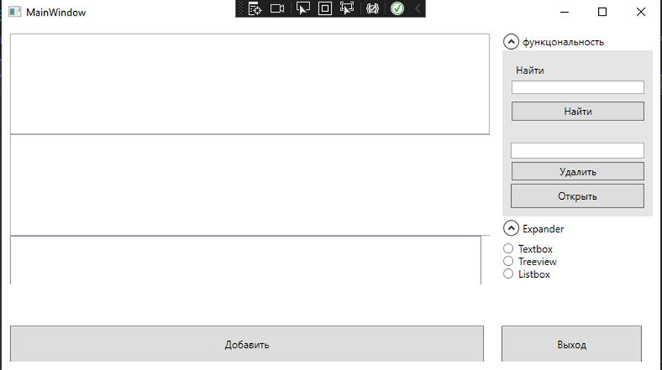

Рисунок 27.1 – Результат работы программы

Источник: собственная разработка